Lab assignment 1:

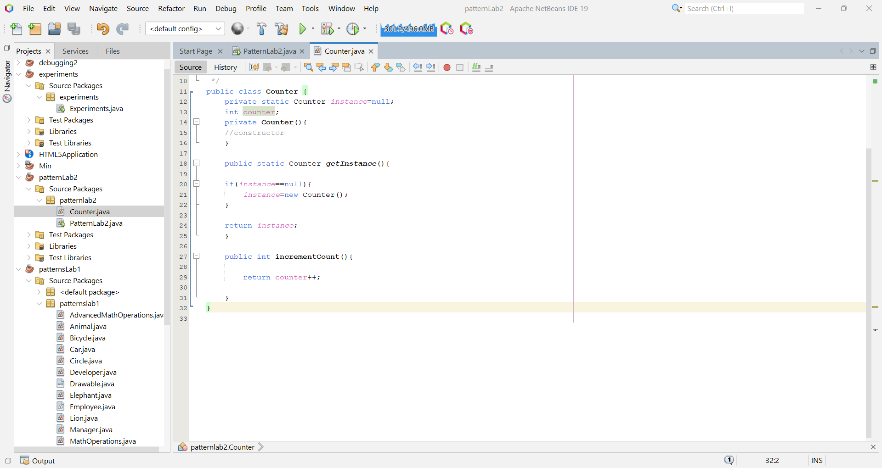Counter class.

Class diagram:

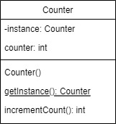

Lab assignment 2:

Class diagram:

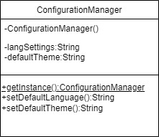

Run:

